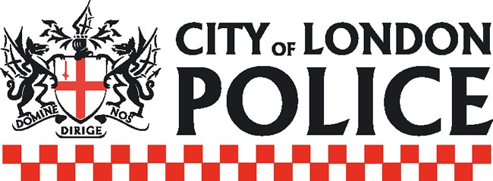

Notice of Misconduct Hearing to be held in public

A misconduct hearing is scheduled to be held:

Date of hearing: Commencing on Monday 29th September 2025, expected to last for 2 days
Time of hearing: 10am
Location of hearing: International Dispute Resolution Centre, 1 Paternoster Square, St Paul’s, London, EC4M 7BQ

The hearing is for PC Andrew JACKS, based at Bishopsgate Police Station, London.

It is alleged that PC JACKS breached the following Standards of Professional Behaviour:

- Authority, respect and courtesy
- Discreditable Conduct

The alleged circumstances are:

Between April 2012 and July 2022, the officer has posted messages on social media which have been deemed as inappropriate, misogynistic and homophobic.

***

No recording or filming of the hearing is permitted.

Applications to view the hearing should be sent by no later than 9am on Friday 26th of September 2025 to the Professional Standards Department inbox: Hearings@cityoflondon.pnn.police.uk

In their application, applicants must state their identity and details of the media company they represent. Identification will be required upon entry. Successful applicants will be notified by email.

In accordance with Regulation 36 of the Police (Conduct) Regulations 2020 it is the Commissioner’s intention to notify the public of the hearing.

The presumption is that a misconduct hearing will be held in public, however there may be some circumstances where this is not appropriate, or where certain parts of the hearing need to be held in private.

